Advanced  Ear  Reflexology  12 CE Hours  for  ARCB, ABMP, NCBTMB &  Many States | 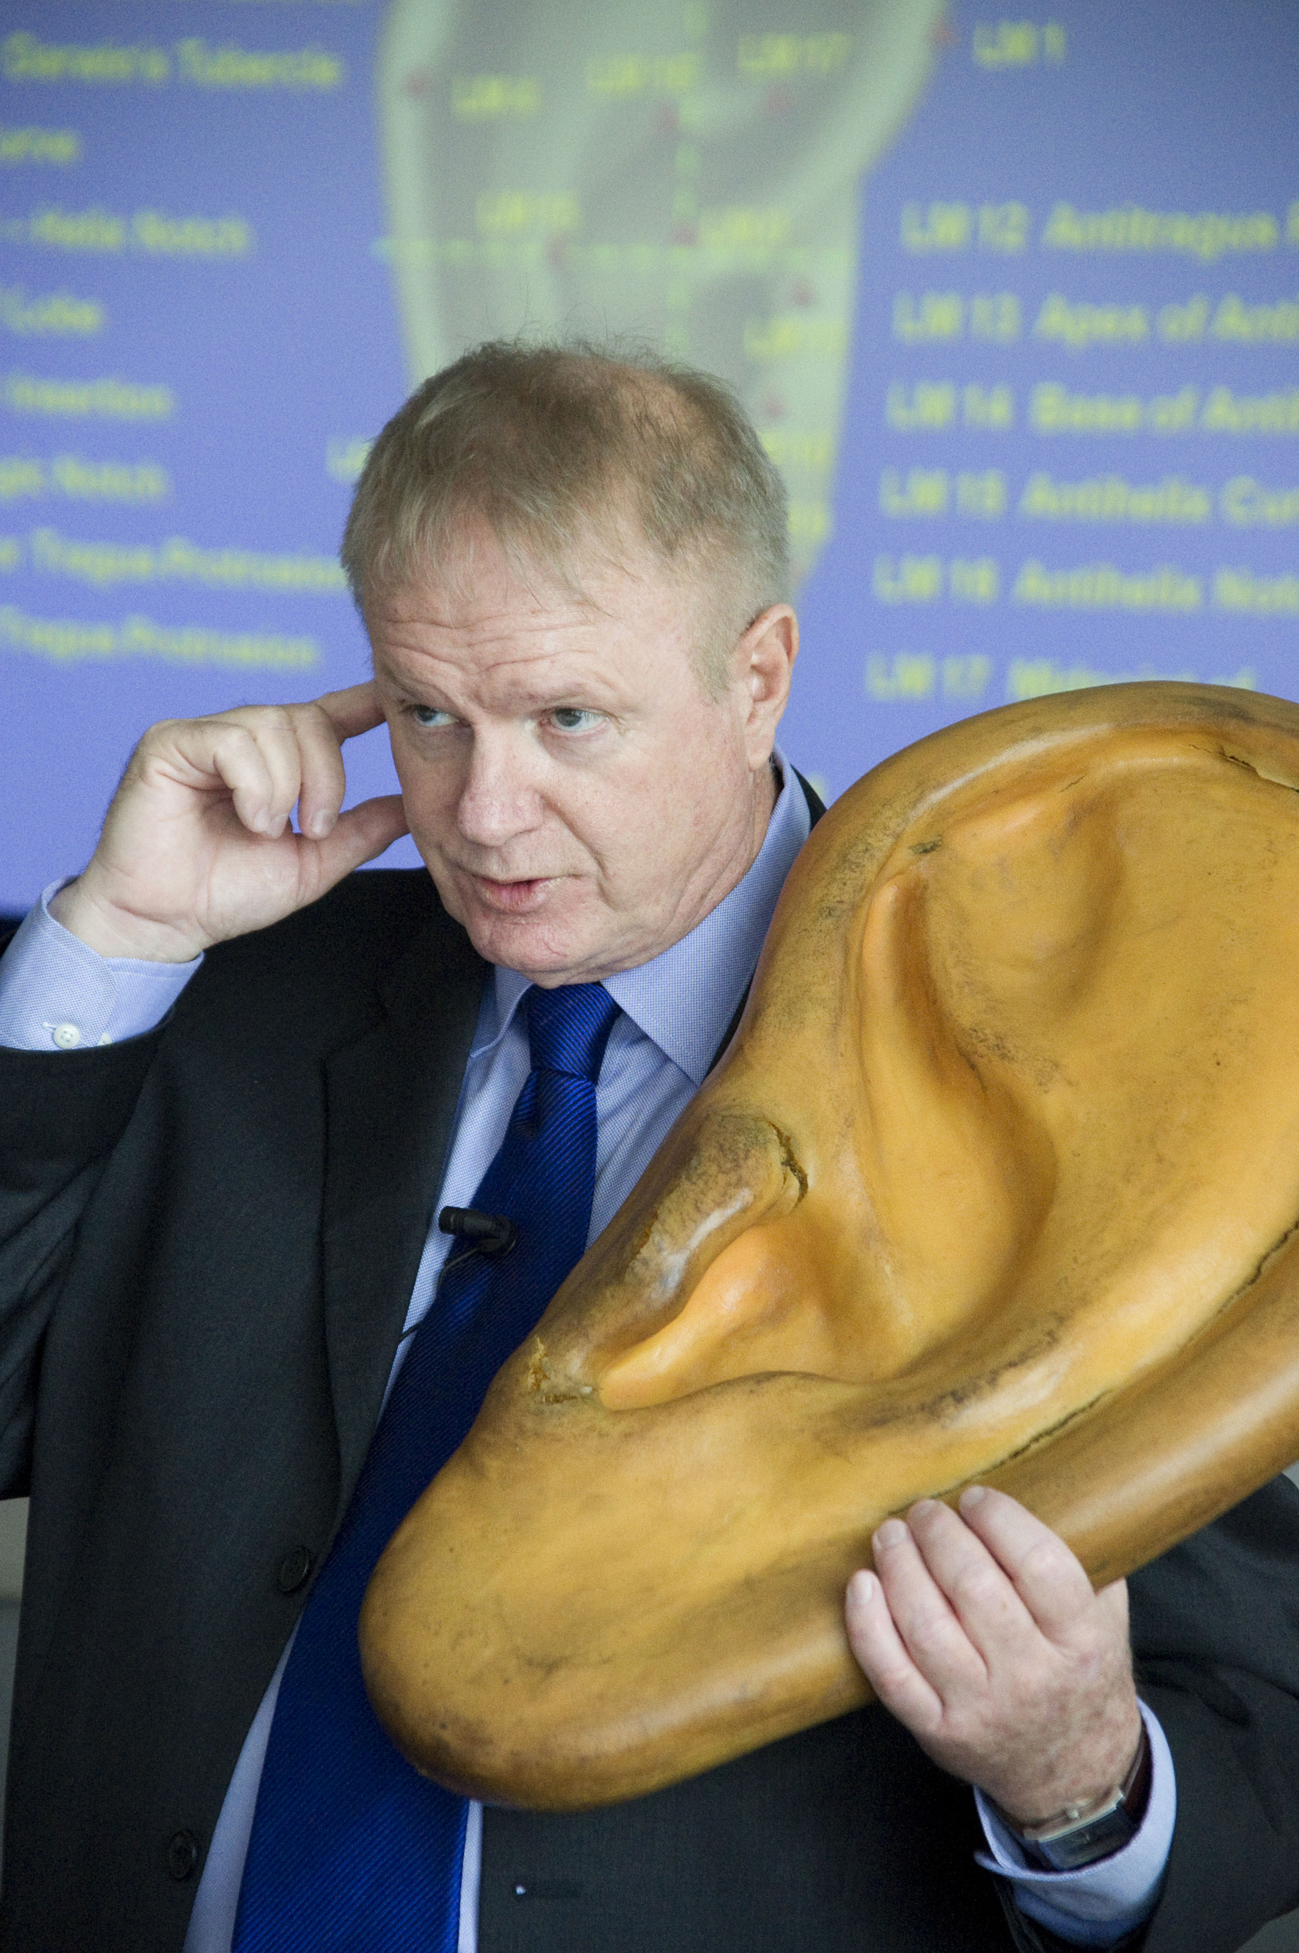

Since Ear Reflexology maps of the body were first discovered during 1957 in France, with further discoveries during 1959 in China, leading medical researchers have discovered hundreds of additional points. Learn the
10 Master Points that have a broad impact on the body, such as: Tranquilizer, Pain Control, Master Oscillation Points. Also, at least 15 Functional Points which can have an impact on special functions of the body, such as: Allergy Point, Hypertension Point, Asthma Point, Constipation Point, Skin Disorders Point, Sleep Disorders Point, will be presented. Also learn Protocols - Combining Ear Reflexology Map Reflexes, Master Points, & Functional Points - for such health challenges as: Addictive Behaviors, Stress Related Disorders, Drug Detoxification, Smoking Withdrawal, Weight Control / Eating Disorders, Chronic Pain, Anxiety, Depression, and Irritability.

Terry Oleson Ph.D. is an internationally known author and lecturer in the field of Auriculotherapy, conducted pioneering research on auricular diagnosis and Auriculotherapy at the UCLA Pain Management Center in Los Angles, California, and serves on the faculty of a number of universities. Terry is acknowledged as one of the world’s leading experts on the power of the French and Chinese Reflexology maps in the outer ears. His book, Auriculotherapy Manual: Chinese and Western Systems of Ear Acupuncture is possibly the most complete book available in the field today.

December 2-3, 2017 Saturday & Sunday 9:30 AM - 5 PM Both Days

Location: 13315 W. Washington Blvd, LA, CA 90066 3rd Floor, Sevenstar Room, near Lincoln Blvd, close to Marina del Rey, 12 minutes from LAX. Free parking. Restaurants nearby. Ask for Hotel list.
Fee: $220 One month early, $240 thereafter. Refund 100% if cancellation by day prior to class. Thereafter, refund less $25. Or, fee may be applied to future class or transferred to another person. Class size limited.
Prerequisite: ***Beginning Ear Reflexology from a hands-on school.
Receive: Document of attendance with class title, hours, school & teachers name, location.
CE Hours: 12 CE Hours for ARCB, ABMP, NCBTMB & Many States

Administrative Address for correspondence & phone calls

American Academy of Reflexology, Bill Flocco, Director, 12719 Sarah Street, Studio City, CA 91604
818 841-7741 eMail: AAReflex@aol.com www.AmericanAcademyofReflexology.com

Scan Mail or Call Your Registration Today Advanced Ear Dec 2-3, 2017
You can also Register online: www.AmericanAcademyofReflexology.com

Please reserve ________ places for me. My check or money order for $ ________________ in enclosed

Please mail this form with check or money order payable to: American Academy of Reflexology

___ Visa ___ MasterCard Number ________ ________ ________ ________ Expiration Date ______ /______/________
Name ________________________________________________________________________________________________
Address _______________________________________________________________________________________________
City ___________________________________________________________ State ________ Zip _______________________
Phone (Home) (________) __________________ (Work) (________) ________________ (Cell) (_________) ______________
eMail Address __________________________________________________________________________________________

